**Data Structures Lecture 10: Graph**

**Graph Search**

– Breadth First Search (BFS): queue (FIFO)

– Depth First Search (DFS): stack (LIFO)

**Depth First Search (DFS)**

: Depth-first search (DFS) is an [algorithm](https://en.wikipedia.org/wiki/Algorithm) for traversing or searching [tree](https://en.wikipedia.org/wiki/Tree_data_structure) or [graph](https://en.wikipedia.org/wiki/Graph_(data_structure)) data structures. The algorithm starts at the [root node](https://en.wikipedia.org/wiki/Tree_(data_structure)#Terminology) (selecting some arbitrary node as the root node in the case of a graph) and explores as far as possible deeper. Stack is needed to go back.

-Time Complexity of DFS : O(|V|+|E|)

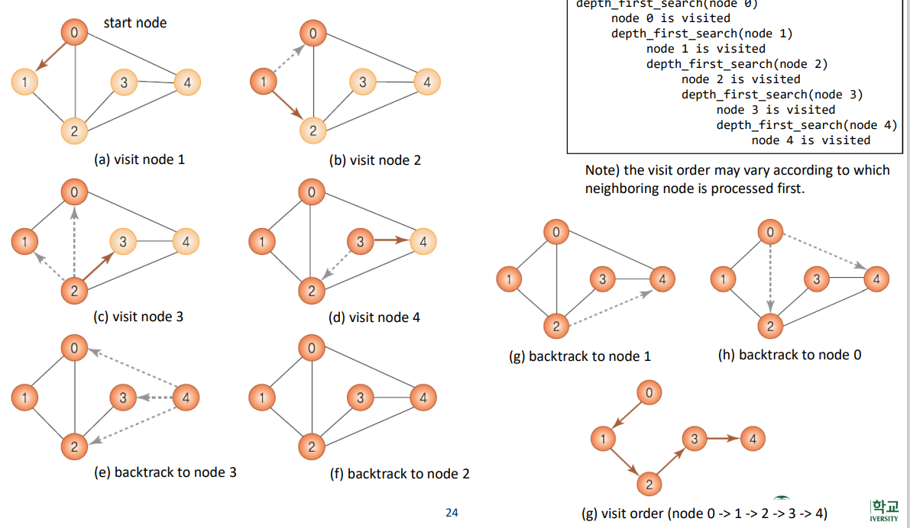

**Breadth first search (BFS)**

**:** Visit the nearest node to the start node and later visit the far nodes. using queue.

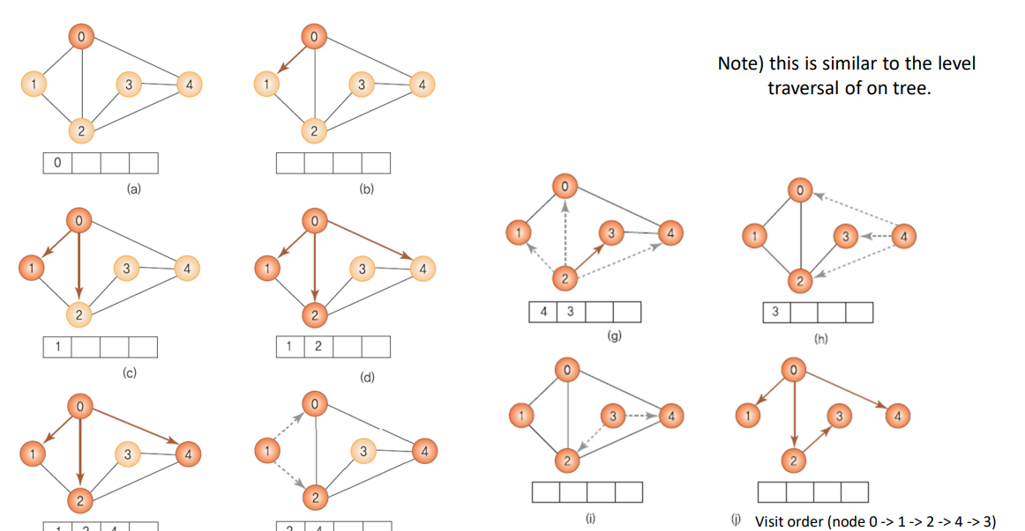

-Time Complexity of BFS : O(|V|+|E|)

**Connected Components**

– A set of maximum connected sub-graphs

– Use DFS or BFS iteratively

**Spanning Tree**

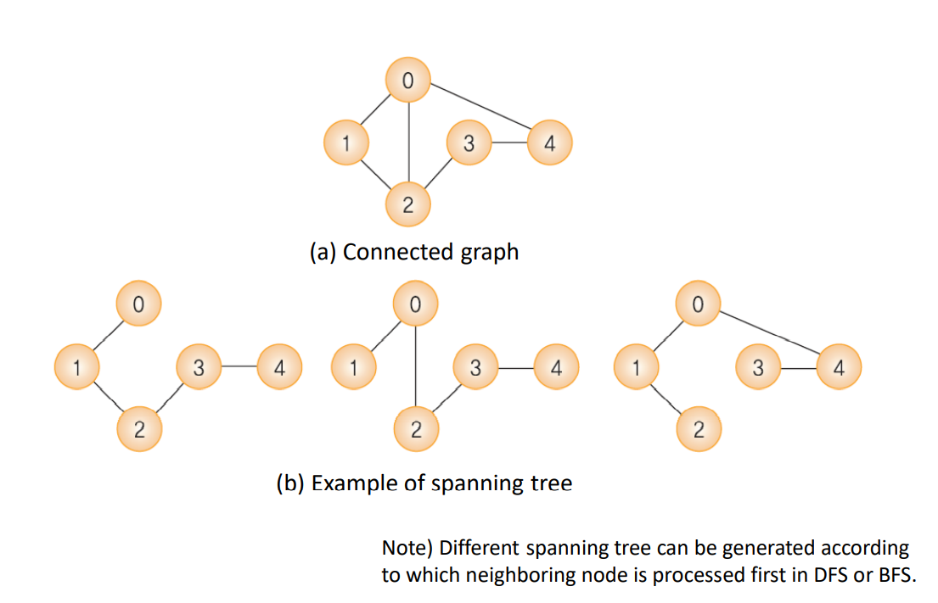

– Tree containing all vertices in the connected graph

– All vertices must be connected and must not contain cycles.

– For a graph with n vertices, its spanning tree has n-1 edges.

– Application Building a network that uses the least number of links: communication network, road network, and distribution network

**=>** a **spanning tree** *T* of an [undirected graph](https://en.wikipedia.org/wiki/Undirected_graph) *G* is a subgraph that is a [tree](https://en.wikipedia.org/wiki/Tree_(graph_theory)) which includes all of the [vertices](https://en.wikipedia.org/wiki/Vertex_(graph_theory)) of *G*. In general, a graph may have several spanning trees, but a graph that is not [connected](https://en.wikipedia.org/wiki/Connected_graph) will not contain a spanning tree.

**Minimum Spanning Tree (MST)**

MST: Connect all vertices in the graph with the smallest costs

– Kruskal algorithm and Prim algorithm

**Kruskal Algorithm**

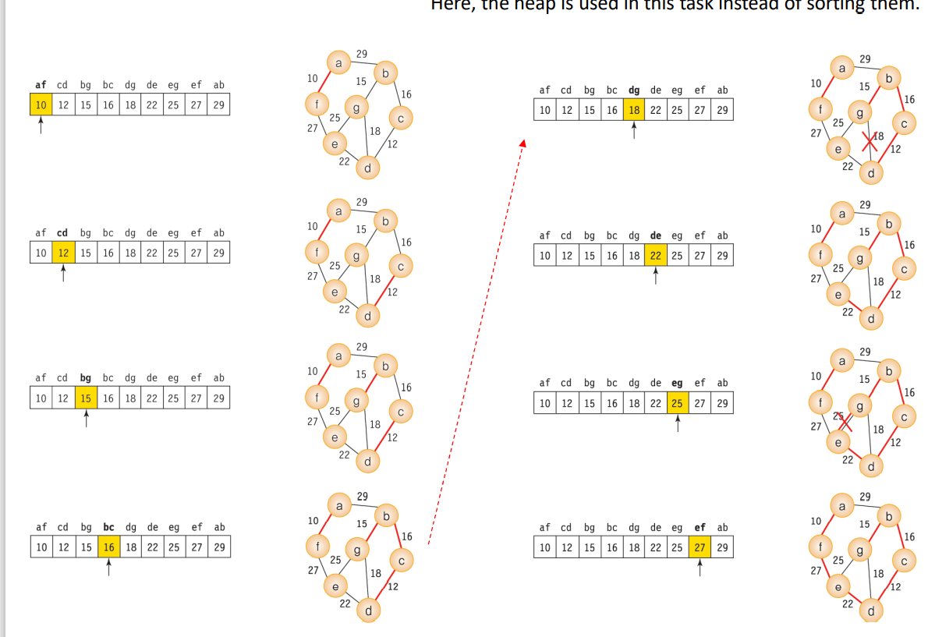

1.Greedy method

• Approach the final result by repeating the process of choosing the best answer at each step

• It is always needed to verify whether greedy methods give optimal results.

2.union-find algorithm

– Generate union of two sets and then find out to which set two elements belong.

– Used for checking the cycle in Kruskal algorithm

**Prim Algorithm**

**:** The MST is progressively constructed, starting from the start vertex.

• Procedure

1. In the beginning, only the start vertex is included in the MST.

2. Select the vertex connected by the edge with the lowest cost among the vertices adjacent to the current MST.

3. Repeat 1-2 until the MST has n-1 edges.